Functional and Non-Functional Requirements: (both are derived from SRS)

*Clearly defined requirements are essential signs on the road that leads to a successful project.

*The establish a formal agreement between a client and a provider that they are both working to reach the same goal.

Types of requirements:

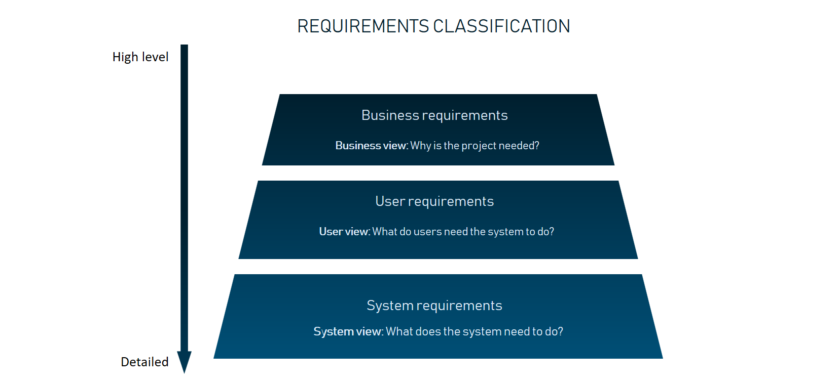

**Functional requirements** describe how a product must behave, what its features and functions.

Generally, functional requirements describe system behavior under specific conditions

e.g.

A search feature allows a user to hunt among various invoices if they want to credit an issued invoice.

Functional requirements are usually written in text and most common formats and dicuments.

* Software requirement specifications document.
* Use cases
* User stories
* Prototypes
* Models and diagrams

**Non-Functional requirements** describe the general characteristics of a system. They are also known as quality attributes.

* Usability
* Security
* Reliability
* Performance
* Scalability

**Design documents and Software prototypes:** Design requirements are usually collected and documented using three main forms that morph into one another.

**Wireframes**: are low-fidelity graphic structure of website or application which help map different product pages with sections and interactive elements.

**Mockups**: once wireframes are ready, they are turned into mockups, usual designs that convey the look and feel of the final product. Eventually mockups can become the final design of the product.

**Design prototypes**: These documents contain visuals and allow for some interface interactions like scrolling, clicking on links, filling forms etc. design document prototypes can be built from scratch using HTML, CSS